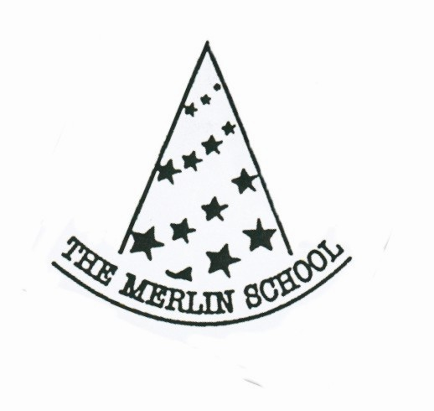

The Merlin School
Person Specification Teaching Assistant

Requirements | Essential or  Desirable? | How  Assessed?
Qualification / Education / Training:  - O Level/GCSE in English, Maths /A Level’s  - Other O Level/GCSE/NVQ L3  - Degree | Essential  Desirable  Desirable | Application Form  Application Form  Application Form
Experience:  - Experience of working in similar role  - Experience of working with children/being around children  - Experience of child development 4/8 yr olds | Desirable  Essential  Essential | Via application Form  and interview  “  “
Knowledge:  - Current affairs  - Knowledge of child development 4/8 | Desirable  Desirable | Via Interview  Via interview & classroom observation
Skills & Competencies:  - Excellent communication skills, particularly verbal and written to suit a variety of audiences i.e. children and parents and to show sufficient understanding and use of English to ensure the well-being of children in their care.  - Ability to process and interpret information  - Ability to manage own workload  - Ability to work Flexibly  - Team work  - Ability to negotiate  - Fluent and competent in written and spoken English | Essential  Essential  Essential  Essential  Essential  Essential  Essential | Via interview and classroom observations  Via interview & ref  Via interview & ref  Via interview & ref  Via interview &ref  Via interview & ref  Via application form/interview
Personal Attribute:  - Self motivated  - Ability to make decisions and use own initiative where necessary  - Creative, comes up with ideas  - Prepared to learn new skills | Essential  Essential  Essential  Essential | Via interview  Via interview  & observation  Via interview  Via interview
Others:  - Ability to use Microsoft Word  - Willing to participate in the other areas of school life  - First Aid | Desirable  Desirable  Desirable | Via interview  Via interview  Via application from

