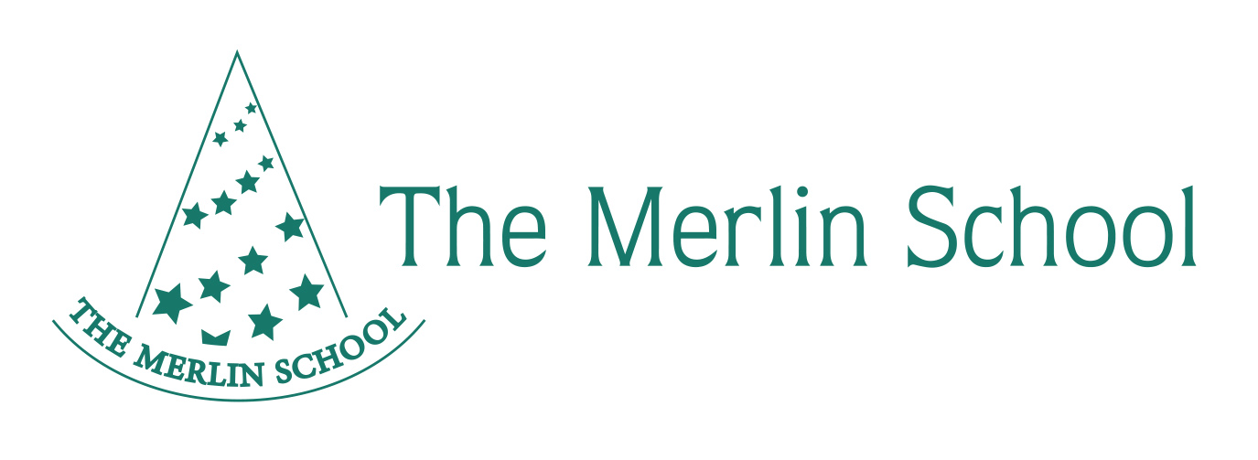

**Merlin School Job Description**

**Teaching Assistant**

* Helping the teacher in preparing class work
* To carry out tasks such as marking, recording children’s work and liaising with teachers re pupil observations
* Following teacher instructions for working with children individually, in groups or as a whole class
* To support children’s learning for e.g. listening to children reading, helping children to develop phonic and comprehension skills
* Helping children change for Sport and accompanying them to the Games Field, helping with Games
* Providing cover as appropriate
* Helping with First Aid where appropriate
* All break duties including helping to serve lunch and helping children with manners and behaviour management
* Photocopying and displaying work, helping create display boards
* Helping to keep the classroom tidy and appropriate for learning
* To carry out such duties as the Headteacher may reasonably request
* To carry out administrative duties as the Secretary and Headteacher may reasonably request
* To always have a concern and responsibility for the safety of children
* To maintain high standards of professionalism including relationships with parents and colleagues
* To maintain loyalty to the School, Chairman and Headteacher
* To be enthusiastic, showing effort and support in the school – “going the extra mile”
* To have a genuine love for young children and an understanding of the way their world works
* The Teaching Assistant must be committed to safeguarding and promoting the welfare of children at all times